Listening
1 (Audio 6) Posłuchaj nagrania. Wybierz poprawne odpowiedzi.
0 What can Adam do?
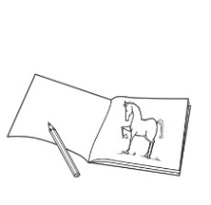  c  a  b |  | 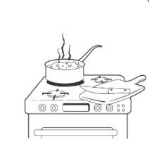

1 Where is Sam’s sister?
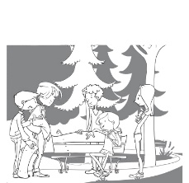  c  a  b | 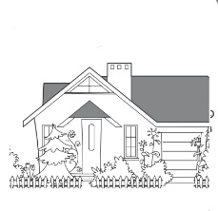 | 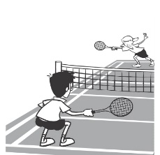

2 What can Mark play?
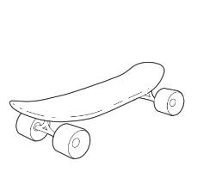  c  a  b | 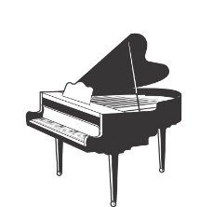 | 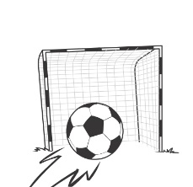

3 What club is on Wednesday?
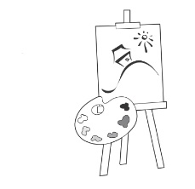  c  a  b | 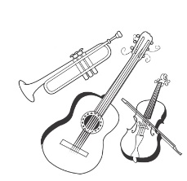 | 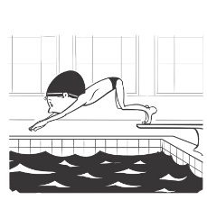

4 What time is the football match on TV?
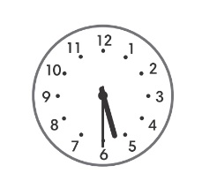  c  a  b | 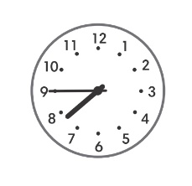 | 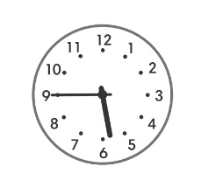

5 What does Ellen’s dad do in the evening?
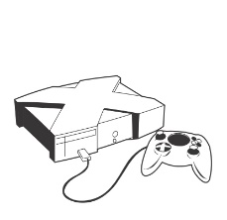  b | c | 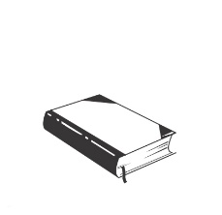
/ 5
a

Vocabulary
2 Uzupełnij tekst słowami z ramki.
breakfast do Mondays Saturdays shower Thursdays to up with
On ⁰ Mondays , Tuesdays, Wednesdays, ¹ and Fridays, I get ²
early and have ³ . Then I go to school.
After school, I ⁴ my homework. In the evening, I listen ⁵ music
or watch TV. Then, I have a ⁶ . I go to bed early.
On ⁷ and Sundays I hang out ⁸ my friends.
/ 8
3 Wpisz w luki brakujące nazwy miesięcy.
January → ⁰ February → ¹ → April → ² → June
³ → August → September → ⁴ → November → December
/ 4

Grammar
4 Uzupełnij zdania czasownikami z nawiasów w odpowiedniej formie.
0 Sam plays (play) football after school.
1 You and your sister (take) great pictures.
2 Anna’s cat (climb) trees.
3 My friends (have) lunch at school.
4 Rob (write) great stories.
5 Ben’s brother (run) fast.
/ 5
5 Przeczytaj wypowiedzi kilku osób i dokończ zdania o nich.
0 Jim: I do karate after school.
Jim does karate after school.
1 Maria: I fix cars and bikes.
Maria
2 Adam: I watch TV in the evening.
Adam
3 Eva: I tidy my bedroom every Friday.
Eva
4 Tom: I have sandwiches for lunch.
Tom
/ 4

6 Ułóż słowa w odpowiedniej kolejności, aby utworzyć poprawne zdania.
0 I / to school / ride my bike / often
I often ride my bike to school.
1 watch TV / they / never / in the morning

2 is / busy on Saturdays / Harry / often

3 is / Olivia / happy / usually

4 go to bed early / on Sundays / always / we

/ 4

Speaking
7 Popatrz na zegary i odpowiedz na pytania.
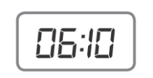 | 0 What time is the film?  It’s at ten past six.
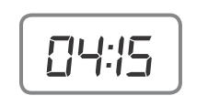 | 1 What time is the match?
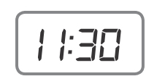 | 2 What time is our French lesson?
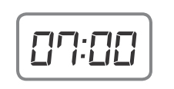 | 3 What time is breakfast?
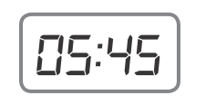 | 4 What time is dinner?
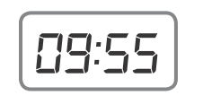 | 5 What time is bedtime?
/ 5

Reading
8 Przeczytaj tekst. Zdecyduj, czy podane zdania są prawdziwe (P), czy fałszywe (F).
Hi! I’m Mandy and I’m twelve years old. I usually get up at seven o’clock and I have a shower. Then, I have breakfast. I usually have orange juice and cornflakes, but sometimes I have milk, eggs and toast.
I don’t walk to school, I ride my bike. I have lessons from half past eight to two o’clock. Then, I go home and have lunch. I do my homework after lunch, but my best friend, Sarah, does her homework in the evening.
On Mondays and Wednesdays, I play tennis in the afternoon. In the evening, I have dinner with my family. Then, we watch TV. I go to bed at nine o’clock from Sunday to Thursday, but on Fridays and Saturdays I go to bed at ten.
0 Mandy is twelve years old. P
1 She always has juice and cornflakes for breakfast.
2 She usually walks to school.
3 She has lunch at home.
4 She does her homework in the evening.
5 She goes to bed at nine o’clock on Tuesdays. / 5

Writing
9 Napisz 40–70 słów o tym, co robisz w czasie wakacji. Skorzystaj z pytań pomocniczych 1–6.
1 When are the summer holidays?
2 What time do you usually get up?
3 What do you do in the morning?
4 What do you do in the afternoon?
5 What do you do in the evening?
6 What time do you go to bed?
The summer holidays are in

/ 10
Your total score: / 50

