Listening
1 (Audio 6) Posłuchaj nagrania. Wybierz poprawne odpowiedzi.
0 What can Adam do?
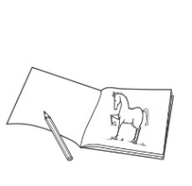  c  a  b |  | 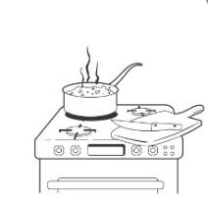

1 Where is Sam’s sister?
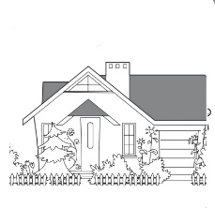  c  a  b | 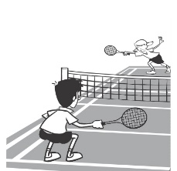 | 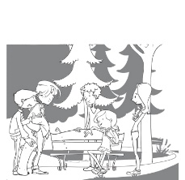

2 What can Mark play?
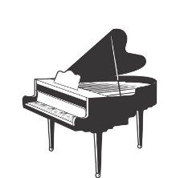  c  a  b | 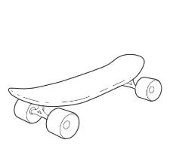 | 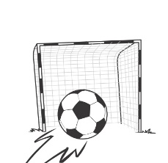

3 What club is on Wednesday?
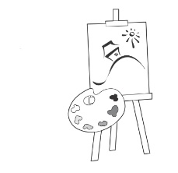  c  a  b | 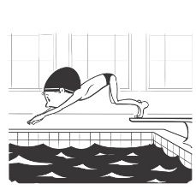 | 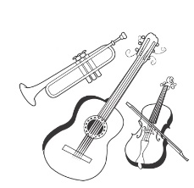

4 What time is the football match on TV?
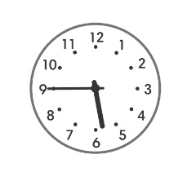  c  a  b | 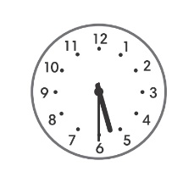 | 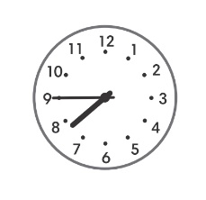

5 What does Ellen’s dad do in the evening?
b | 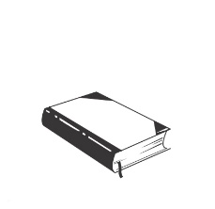  c | 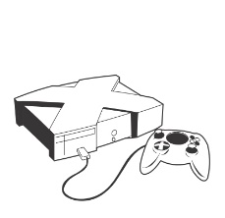
/ 5
a

Vocabulary
2 Uzupełnij tekst słowami z ramek.
get do Mondays shower Wednesdays
On ⁰ Mondays , Tuesdays, ¹ , Thursdays and Fridays,
I ² up early and have a ³ .
Then, I have breakfast and I go to school.
After school, I ⁴ my homework.
In the evening, I have ⁵ .
Then, I watch TV or listen ⁶ music. I go to bed early.
On ⁷ and Sundays I hang ⁸ with my friends.
dinner out to Saturdays

/ 8

3 Uzupełnij luki nazwami miesięcy z ramki.
April August February June November

January |  | ⁰ February |  | March
¹ |  | May |  | ²
July |  | ³ |  | September
October |  | ⁴ |  | December

/ 4

Grammar
4 Wybierz poprawne odpowiedzi.
0 We have / has lunch at school.
1 Sam play / plays football after school.
2 My friends take / takes great pictures.
3 Anna’s sister run / runs fast.
4 You and your brother write / writes great stories.
5 Rob’s cat climb / climbs trees.
/ 5

5 Przeczytaj wypowiedzi Toma i dokończ zdania o nim.
I do karate after school.
0
Tom does karate after school.
I have eggs for breakfast.
1
Tom eggs for breakfast.
I tidy my bedroom every Saturday.
2
Tom his bedroom every Saturday.
I watch TV in the evening.
3
Tom TV in the evening.
I fix cars and bikes.
4
Tom cars and bikes.
/ 4

6 Ułóż słowa w poprawnej kolejności, aby uzupełnić zdania.
0 I / ride / often
I often ride my bike to school.
1 go / always / they
to bed early on Monday.
2 does / Harry / usually
his homework before dinner.
3 often / cycles / Bella
to school.
4 watch / we / never
TV in the morning.
/ 4

Speaking
7 Połącz zdania z właściwymi zegarami.
0 It’s ten past six. | a | 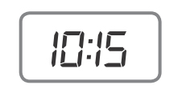
1 It’s nine o’clock. | b | 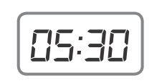
2 It’s quarter past ten. | c | 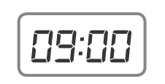
3 It’s quarter to one. | d | 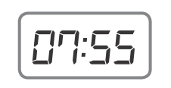
4 It’s half past five. | e | 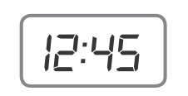
5 It’s five to eight. | f | 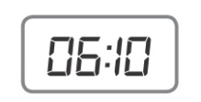
/ 5

Reading
8 Przeczytaj tekst. Zdecyduj, czy podane zdania są prawdziwe (P), czy fałszywe (F).
(0–2) Hi! I’m Mandy and I’m twelve years old.
I usually get up at seven o’clock and I have
a shower. Then, I have breakfast. I usually have orange juice and cornflakes, but sometimes I have milk, eggs and toast.
(3) I don’t walk to school, I ride my bike. I have lessons from half past eight to two o’clock.
Then, I go home and have lunch. I do my homework after lunch, but my best friend, Sarah, does her homework in the evening.
(4–5) On Mondays and Wednesdays, I play tennis in the afternoon. In the evening, I have dinner with my family. Then, we watch TV. I go to bed at nine o’clock from Sunday
to Thursday, but on Fridays and Saturdays I go to bed at ten.
0 Mandy is twelve years old. P
1 She usually has a shower in the morning.
2 She always has milk, eggs and toast for breakfast.
3 She has lunch at shool.
4 She sometimes plays tennis in the afternoon.
5 She goes to bed at nine o’clock on Fridays.
/ 5

Writing
9 Napisz 40–70 słów o tym, co robisz w czasie wakacji. Skorzystaj z pytań pomocniczych 1–6.
1 When are the summer holidays?
2 What time do you usually get up?
3 What do you do in the morning?
4 What do you do in the afternoon?
5 What do you do in the evening?
6 What time do you go to bed?
The summer holidays are in

/ 10
Your total score: / 50

